Mark Anthony S. Andes

1.) A & D

2.) C

3.) C

4.)

* 
* 

OUTPUT:

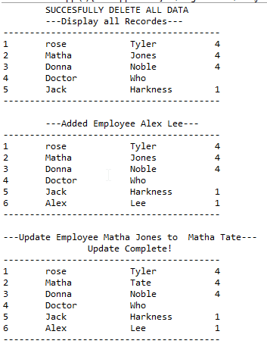

5.) **Class.forName** is to load a JDBC driver implementation, JDBC Driver classes that register the driver with Driver Manager.

6.) **Statement** –always proceed though the incoming SQL query ,Compile ,Plan ,Execute query

**PreparedStatement**- pre-optimization is performed immediately and also the effect is to lessen the load on the database.

7.) Connection connection = DriverManager.getConnection(URL, userName, UserPassword);

Statement sql = con.createStatement();

ResultSet result =sql.executeQuery("SELECT * FROM EMPLOYEE ORDER BY ID");

…

result.close();

sql.close();

connection.close();